Is the world’s most important asset market broken?

Regulators have proposed radical changes to how Treasuries are traded, to the dismay of investors

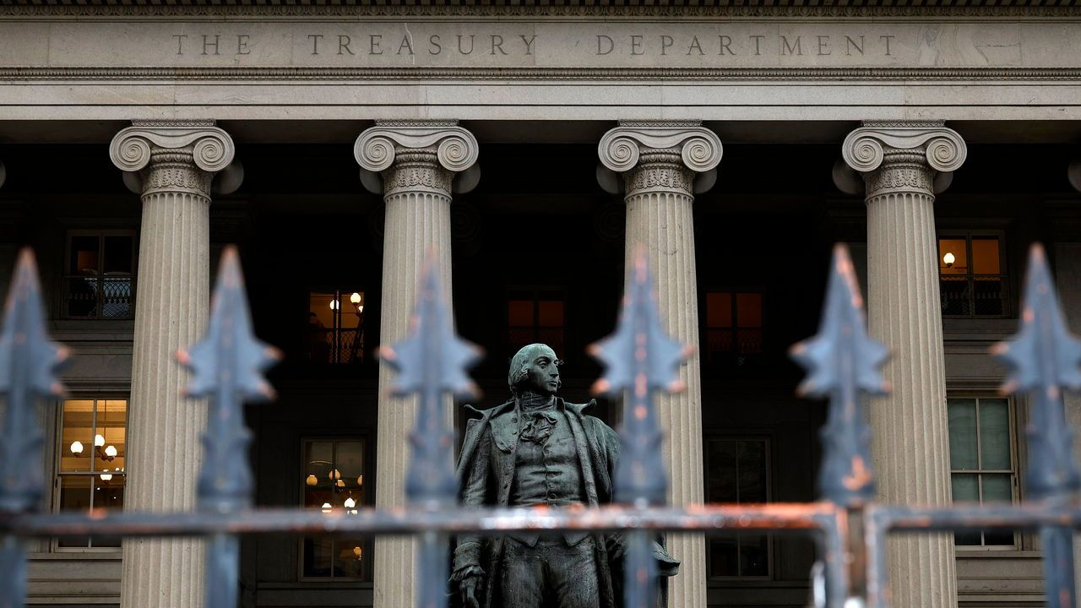

Dec 3rd 2023 | WASHINGTON, DC

In 1790 america’s finances were in a precarious state: debt-servicing costs were higher than revenues and government bonds traded at 20 cents on the dollar. Alexander Hamilton, the country’s first treasury secretary, wanted a deep and liquid market for safe government debt. He understood the importance of investor confidence, so proposed honouring all debts, including those of states, and offering to swap old debt, at par, for new bonds with a lower interest rate. This was controversial. Shouldn’t speculators who picked up cheap debt in secondary markets be paid less? Yet Hamilton could not be swayed: “When the credit of a country is in any degree questionable, it never fails to give an extravagant premium, in one shape or another, upon all the loans it has occasion to make.”

1790年，美国的财政状况非常不稳定：债务支付成本高于收入，政府债券以每美元20美分的价格交易。作为美国第一任财政部长，亚历山大·汉密尔顿希望建立一个稳定且流动性强的低风险的政府债券市场。他深知投资者信心的重要性，因此提出了兑现所有债务的建议，包括各州的债务，提议以等额兑换旧债务，换取利率较低的新债券。这个提议引起了争议。有人认为在二级市场购得廉价债务的投机者理应获得较少的回报。然而，汉密尔顿坚持自己的立场：“当一个国家的信用无论受到何种程度的质疑，它总会以高的的离谱的价格来借贷”

More than two centuries later American politicians are busy undermining Hamilton’s principles. [Debt-ceiling brinkmanship](https://www.economist.com/finance-and-economics/2023/05/03/america-faces-a-debt-nightmare) has pushed America towards a technical default. Rising interest rates and [incontinent spending](https://www.economist.com/briefing/2023/02/02/americas-government-is-spending-lavishly-to-revive-manufacturing) have seen debt balloon: the country’s total stock of it now amounts to $26.6trn (96% of gdp), up from $12.2trn (71% gdp) in 2013. [Servicing costs](https://www.economist.com/graphic-detail/2023/10/11/america-may-soon-be-spending-more-on-debt-service-than-defence) come to a fifth of government spending. As the Federal Reserve reduces its holdings of Treasuries under quantitative tightening and issuance grows, investors must swallow ever greater quantities of the bonds.

两个多世纪后，美国政治家们在逐渐违背汉密尔顿所倡导的原则和理念。债务上限的边缘政策已将美国推向技术性违约的边缘(也就是说美国将面临无法按时偿还债务的风险)。利率不断上升和开支失控导致债务急剧膨胀：目前，美国的总债务规模达到了26.6万亿美元（占国内生产总值的96%），而2013年时为12.2万亿美元（占国内生产总值的71%）。偿还债务的成本已经占到了政府支出的五分之一。随着美联储不断减少国债的持有量，同时国债发行量不断增加，投资者必须不断咽下更大数量的债券。

All this is straining a market that has malfunctioned frighteningly in the past. American government bonds are the bedrock of global finance: their yields are the “risk-free” rates upon which all asset pricing is based. Yet such yields have become extremely volatile, and measures of market liquidity look thin. Against this backdrop, regulators worry about the increasing activity in the Treasury market carried out by leveraged hedge funds, rather than less risky players, such as foreign central banks. A “flash crash” in 2014 and a spike in rates in the “repo” market, where Treasuries can be swapped for cash, in 2019, first raised alarms. The Treasury market was then overwhelmed by fire sales in 2020, as long-term holders dashed for cash, before the Fed stepped in. In November a cyberattack on icbc, a Chinese bank, disrupted settlement in Treasuries for days.

所有这一切都给一个在过去曾经出现过令人恐惧故障的市场带来了巨大压力。美国政府债券是全球金融的基石：它们的收益率是所有资产定价所依据的“无风险”利率。然而，这些收益率变得极其波动，市场流动性的指标看起来薄弱。在此背景下，监管机构担心的是杠杆式对冲基金等高风险参与者在国债市场上的活动不断增加，而不是像外国央行等风险较小的参与者。2014年的“闪电崩盘”和2019年“回购”市场（可以将国债兑换成现金的市场）利率的激增首次引起了警报。然后，2020年长期持有者为了现金而抛售国债，导致国债市场不堪重负，直到联邦储备系统介入。去年11月，中国工商银行遭受网络攻击，导致国债结算被打乱多天。

Regulators and politicians want to find a way to minimise the potential for further mishaps. New facilities for repo markets, through which the Fed can transact directly with the private sector, were put in place in 2021. Weekly reports for market participants on secondary trading have been replaced with more detailed daily updates, and the Treasury is mulling releasing more data to the public. But these fiddles pale in comparison to reforms proposed by the [Securities and Exchange Commission](https://www.economist.com/finance-and-economics/2022/10/26/can-gary-gensler-solve-every-problem-in-american-finance) (sec), America’s main financial regulator, which were outlined in late 2022. The sec has invited comment on these plans; it may begin to implement them from early next year.

监管机构和政治家们希望找到一种方式来最大限度地减少进一步意外事件发生的可能性。2021年，回购市场设立了新的机制，使得美联储能够与私营部门直接进行交易。市场参与者的每周交易报告已被更详细的每日更新所取代，财政部正在考虑向公众发布更多的数据。但是，与美国主要金融监管机构证券交易委员会（SEC）在2022年末提出的改革建议相比，这些调整显得微不足道。SEC已经受邀请对这些计划进行评论，可能从明年初开始实施。

The result has been fierce disputes about the extent and causes of problems in the Treasury market—and the lengths regulators should go to repair them. A radical overhaul of Treasury trading comes with its own risks. Critics say that the proposed changes will needlessly push up costs for the Treasury. Do they have a point?

由此引发了对国债市场问题的程度和原因以及监管机构应该采取何种措施修复的激烈争议。。对国债交易的彻底改革同时也存在可能引发其他问题或给市场带来不稳定性的风险。批评人士称，拟议的改变将不必要地增加财政部的成本。他们的观点有道理吗？

## Repo repair

The modern Treasury market is a network of mind-bending complexity. It touches almost every financial institution. Short-term bills and long-term bonds, some of which pay coupons or are linked to inflation, are issued by the Treasury. They are sold to “primary dealers” (banks and broker dealers) in auctions. Dealers then sell them to customers: foreign investors, hedge funds, pension funds, firms and purveyors of money-market funds. Many buyers raise money to buy Treasuries using the overnight repo market, where bonds can be swapped for cash. In secondary markets high-frequency traders often match buyers and sellers using algorithms. Participants, in particular large asset managers, often prefer to buy Treasury futures—contracts that pay the holder the value of a specific Treasury on an agreed date—since it requires less cash up front than buying a bond outright. Each link in the chain is a potential vulnerability.

现代国债市场是一个令人费解的复杂网络，几乎涉及到每个金融机构。财政部发行短期票据和长期债券，其中一些支付利息或与通胀挂钩。它们通过拍卖销售给“主要交易商”（银行和经纪商）。交易商然后将它们卖给客户：外国投资者、对冲基金、养老基金、公司和货币市场基金供应商。许多买家通过隔夜回购市场筹集资金来购买国债，即债券可以兑换成现金(换句话说，他们可以将债券作为抵押品，从出借资金的机构那里借到所需的现金。这样他们就能够用这笔现金来购买国债)。在次级市场，高频交易商经常使用算法来匹配买家和卖家。参与者，特别是大型资产管理公司，通常更喜欢购买国债期货合约，即在约定日期向持有人支付特定国债的价值，因为这样需要的现金比直接购买债券要少。链条中的每个环节都是潜在的漏洞。

The most important of the sec’s proposals is to mandate central clearing, under which trading in the Treasury and repo markets would pass through a central counterparty, rather than occur on a bilateral basis. The counterparty would be a buyer to every seller and a seller to every buyer. This would make market positions more transparent, eliminate bilateral counterparty risk and usher in an “all to all” market structure, easing pressure on dealers to intermediate trades. Nate Wuerffel of bny Mellon, an investment bank, has written that central-clearing rules will be put in place relatively soon.

SEC最重要的提议之一是强制中央清算，即国债和回购市场的交易将通过一个中央对手方进行，而不是以双边方式进行。这个对手方将成为每个卖家的买家，也将成为每个买家的卖家。这将使市场头寸更加透明，消除双边对手方风险，并引入一个“所有人对所有人”的市场结构，减轻交易商的中介压力。投资银行bny Mellon的纳特·维尔费尔表示，中央清算规则将很快实施。(市场头寸更加透明意味着交易参与者可以更清楚地了解市场中各方的持仓和风险暴露。通过中央清算及其他透明度措施，市场参与者能够更准确地评估和监控他们自己以及其他交易方的头寸。这种透明度有助于减少信息不对称和潜在风险，并提供更全面和准确的市场情报，使交易更加公平和高效。)

Yet the sec’s most controversial proposal concerns the so-called basis trade that links the market for Treasuries to the futures market. When buying a futures contract investors need only post “initial margin”, which represents a fraction of the face value of the Treasury. This is often easier for asset managers than financing a bond purchase through the repo market, which is more tightly regulated. As such, there can be an arbitrage between cash and futures markets for Treasuries. Hedge funds will go short, selling a contract to deliver a Treasury, in the futures market and then buy that Treasury in the cash market. They often then repo the Treasury for cash, which they use as capital to put on more and more basis trades. In some cases funds apparently rinse and repeat this to the extent that they end up levered 50 to one against their initial capital.

然而，SEC最具争议的提议是关于将国债市场与期货市场联系在一起的基差交易。购买期货合约时，投资者只需提供“初始保证金”，该保证金只是国债面值的一小部分。这对于资产管理公司来说通常比通过受更严格监管的回购市场融资购买债券更容易。因此，现金市场和国债期货市场之间可能存在套利机会。对冲基金会在期货市场卖出交付国债的合约，然后在现金市场购买该国债(对冲基金通过在期货市场卖出合约来做空，意味着他们预期国债的价格会下跌。他们承诺将来交付国债，即卖出一个合约。然后，他们在现金市场购买同样的国债，以便在将来履约时交付。通过这种方式，对冲基金可以从国债价格的下跌中获利。)。他们通常会将国债进行回购以获取现金，然后将该现金用作资本进行更多的基差交易。在某些情况下，基金显然会反复进行这种操作，以至于最终他们的杠杆比例可达到50倍，即以他们的初始资本为基础放大50倍。

At most times, this trade is pretty low risk. But in times of market stress, such as in 2020, when Treasury prices swung wildly, futures exchanges will send out calls to hedge funds for more margin. If funds cannot access cash quickly they sometimes must close their positions, prompting fire sales. The unwinding of basis trades in 2020 may have exacerbated market volatility. Therefore the sec has proposed that hedge funds which are particularly active in the Treasury market should be designated as broker-dealers and forced to comply with stricter regulations, instead of the simple disclosure requirements that they currently face. It is also considering new rules that would limit the total leverage hedge funds can access from banks.

在大多数时候，这种交易风险相对较低。但是在市场压力大的时候，比如2020年国债价格剧烈波动时，期货交易所会要求对冲基金提供更多的保证金。如果基金无法迅速获取现金，它们有时不得不平仓，引发抛售。2020年基差交易的解除可能加剧了市场的波动性。因此，SEC提议将在国债市场中特别活跃的对冲基金指定为经纪人-交易商，并强制其遵守更严格的监管规定，而不是目前所面对的简单信息披露要求。SEC还在考虑制定新规定，限制对冲基金从银行获得的总杠杆比例。(SEC提议将在国债市场中特别活跃的对冲基金指定为经纪人-交易商，这意味着它们将被要求承担更多的责任和义务，并受到更严格的监管。相比目前所面临的仅需满足信息披露要求，这些对冲基金将需要更加严格地遵守监管规定。这一举措旨在加强对这些对冲基金的监督和控制，以防范和减少潜在的风险，维护市场的稳定性和公平性。)

This has infuriated those who make money from the manoeuvre. In October Ken Griffin, boss of Citadel, the world’s most profitable hedge fund, argued that the regulator was simply “searching for a problem”. He pointed out that the basis trade reduces financing costs for the Treasury by enabling demand in the futures market to drive down prices in the cash market.

这让那些从这种操作中获利的人感到愤怒。去年十月，全球利润最高的对冲基金Citadel的老板Ken Griffin认为，监管机构只是在“寻找问题”。他指出，基差交易通过使期货市场的需求推动现金市场的价格下降，从而降低了国债的融资成本。

Will policymakers hold firm? In a sign of diverging opinions between the sec and the Treasury, Nellie Liang, an undersecretary at the finance ministry, recently suggested that the market may not be functioning as badly as is commonly believed, and that its flaws may reflect difficult circumstances rather than structural problems. After all, market liquidity and rate volatility feed into each other. Thin liquidity often fosters greater rate volatility, because even a small trade can move prices—and high volatility also causes liquidity to drop, as it becomes riskier to make markets.

决策者会坚持立场吗？SEC和财政部之间意见分歧的迹象表明，财政部副部长Nellie Liang最近暗示市场可能并不像普遍认为的那样糟糕，而其缺陷可能反映了困难的环境而非结构性问题。毕竟，市场流动性和利率波动相互影响。流动性不足往往会培养更大的利率波动，因为即使一笔小额交易也可能影响价格，而高波动性也会导致流动性下降，因为市场变得更加具有风险。

Moreover, high volatility can be caused by wider events, as has been the case in recent years, which have been unusually lively. It is far from certain that periods of extreme stress, like March 2020 or the chaos caused in the British gilt market when derivative bets made by pension funds blew up, could be avoided with an alternative market structure.

此外，高波动性可能是由更广泛的事件引起的，就像近年来的情况一样，这些年份异常活跃。目前还远不能确定，在类似2020年3月那样的极端压力时期，或者养老基金投资的衍生品交易引发英国国债市场混乱时，是否可以通过替代的市场结构来避免这种情况的发生。

In addition to the proposals from the sec, the Treasury is working on its own measures to improve how the market functions. These include data gathering and transparency, and beginning buybacks. Buybacks would involve the Treasury buying up older, less liquid issuance—say, ten-year bonds issued six months ago—in exchange for new and more liquid ten-years, which it is expected to start doing from 2024. The Treasury has acknowledged that leverage practices, which make the basis trade possible, warrant investigation, but Ms Liang has also said that there are upsides to the basis trade, such as increased liquidity.

除了SEC的提议外，财政部正在制定自己的措施，以改善市场的运行方式。这些措施包括数据收集和透明度的提高，以及开始回购操作。回购操作将涉及财政部购买较早、流动性较低的发行债券，比如六个月前发行的十年期债券，以换取新的、更具流动性的十年期债券，预计从2024年开始实施。财政部已经承认，使基差交易成为可能的杠杆实践值得调查，但Liang女士也表示，基差交易也有其好处，比如增加了流动性。

Hamilton, the father of the Treasury market, could not have envisaged the vast network of institutions that make up its modern version. Yet he did have a keen appreciation for the role of speculators, who stepped in to buy Treasuries when bondholders lost faith or needed cash. He would have been far more concerned with politicians rolling the dice on defaulting and the growing debt stock than he would have been by enthusiastic intermediators. Although plenty of his successors’ suggestions have widespread support—such as buybacks and central clearing—they would do well to remember his aversion to snubbing those keen to trade. ■

汉密尔顿，国债市场的奠基人，无法预见到构成现代版市场的庞大机构网络。然而，他对投机者的角色有着深刻的认识，当债券持有人失去信心或需要现金时，投机者会介入购买国债。与对热情的中介者相比，他更关心政治家们冒险违约和不断增长的债务。尽管他的许多继任者的建议得到了广泛支持，比如回购和中央结算，但他们应该记住他不愿冒犯那些渴望交易的人